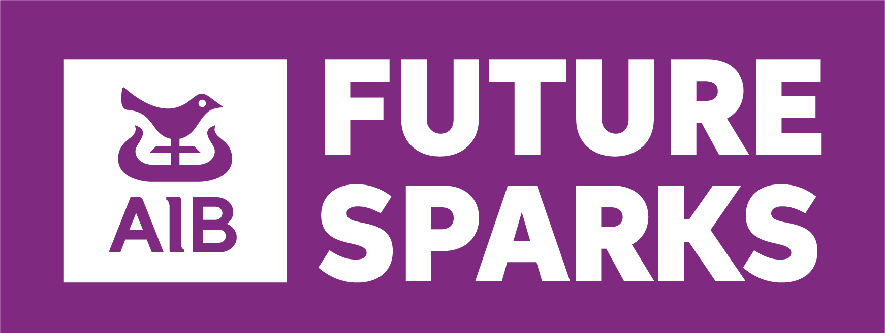
AIB Future Sparks School Impact Awards Submission Form 2025/26

This form should be used to submit a school entry for the AIB Future Sparks School Impact Awards. The AIB Future Sparks School Impact Awards is only available to students currently enrolled in second-level education in the Republic of Ireland, between the ages of 12 and 19. The closing date for submissions is 13th February 2026.

*Required fields

School Roll Number:*

Role of Submitting Teacher:*

School Name (as you would like it to be presented):*

Teacher Email Address:*

Name of the Submitting Teacher/Principal:*

Teacher Mobile Number:*

Who was the beneficiary? I.e. the individual, organisation, community group etc. who benefitted from the endeavour undertaken to effect positive change*

Are you a Gaelscoil? (Yes/No)*

Pillar*
What you did may apply under more than one of these headings. However, for the purpose of adjudication, only one can be selected:
Financial
Environmental
Social

Group size (please select only one):*
Large group (35 students+)
Small group (2-34 students)
Individual (1 student)

Age group:*
Junior (1st - 3rd Year)
Senior (TY - 6th Year)
Mixed (Junior and Senior Students)

If entering a small group or individual, please include the name of the student(s) involved (Optional)

Question 1. Title of Project* (Mandatory)

Question 2. Give a brief description of your project (pillar, what your project was about, who it helped, who worked on your project, outcome etc)* (Mandatory)

Question 3. Tell us about the act of social responsibility that the group participated in this year.* (Mandatory)
Please note this must have taken place between March 2025 and February 2026.

Question 4. How did your actions impact you or the community?* (Mandatory)

Question 5. What did you or others in the community learn from this experience?* (Mandatory)

Question 6. Is there anything else you would like to tell us? (Optional)

*Supporting files can be sent as an attachment

Data Protection - Use of Information Notice
Any information provided by you in this submission form is required for the purpose of administering the AIB Future Sparks School Awards and AIB Future Sparks Programme, and will be retained and used solely for this purpose. If you choose not to provide this information, your application to participate in the AIB Future Sparks School Awards cannot proceed. We share your information with Real Event Management Ltd T/A Real Nation to manage the AIB Future Sparks Programme. Your information will be stored for a period of one year after the AIB Future Sparks Programme has completed. For further information on data protection at AIB (including your rights) visit our website at www.aib.ie/ dataprotection.
I confirm that I have read, understand and agree with the above statement
I have read and hereby accept all terms and conditions
I confirm I hold written parental/guardian consent in respect of all students I am entering into the AIB Future Sparks School Impact Awards

